
IOT BASED SMART PARKING SYSTEM

PROJECT REPORT

Submitted by
SARANKISHORE P | (25EC203)
SHARVESH RAHUL B | (25EC213)
vybhavi r | (25EC248)
shivani k | (25EC216)

in partial fulfillment for the award of the degree of

BACHELOR OF ENGINEERING
in
ELECTRONICS AND COMMUNICATION ENGINEERING

KPR INSTITUTE OF ENGINEERING AND TECHNOLOGY (AUTONOMOUS)
ARASUR, COIMBATORE 641 407

BONAFIDE CERTIFICATE

Certified that this project report titled “IOT BASED SMART PARKING SYSTEM ” is the bonafide work of “SARANKISHORE P, SHARVESH RAHUL B , VYBHAVI R, SHIVANI K” who carried out the project work under my supervision.

SIGNATURE | SIGNATURE
Dr. E. RANJITH KUMAR, Ph.D | Dr.S. BHUVANESWARI, Ph.D
HEAD OF THE DEPARTMENT | SUPERVISOR
Department of Physics,  KPR Institute of Engineering and Technology, Arasur,  Coimbatore – 641 407. | Department of Physics,  KPR Institute of Engineering and Technology, Arasur,  Coimbatore – 641 407.

Submitted for project viva-voce examination conducted on …………….

INTERNAL EXAMINER I INTERNAL EXAMINER II
ACKNOWLEDGMENT

We express our sincere thanks and profound gratitude to Dr. K. P. Ramasamy, Chairman, and Ms. Gayathri Anandakrishnan, Secretary, KPR Group of Institutions, for providing an excellent academic environment and for their visionary leadership and unwavering support for research and innovation.

We are deeply grateful to Dr. A. M. Natarajan, Chief Executive and Dr. R. Devi Priya, Principal, KPR Institute of Engineering and Technology, for their esteemed guidance and for fostering a culture of academic excellence.

Our sincere gratitude to the project leadership team, including Dr. S. Bhuvaneswari, Project Coordinator, for their structured oversight and timely advice.

We are especially thankful to Dr. E. Ranjith Kumar, Professor and Head, Department of Physics, for his support. We also extend our heartfelt thanks to our beloved family, faculty members, supporting staffs and friends for their unwavering support and motivation.

SARANKISHORE P (25EC203)

SHARVESHRAHUL B (25EC213)

VYBHAVI R (25EC248)

SHIVANI K (25EC216)

ABSTRACT
The rapid growth of urbanization has led to an increase in the number of vehicles, resulting in severe parking issues in cities. Traditional parking systems are inefficient, time-consuming, and contribute to traffic congestion and fuel wastage. To overcome these challenges, an Internet of Things (IoT)-based Smart Parking System is proposed.

This system uses sensors, microcontrollers, and wireless communication technologies to monitor the availability of parking spaces in real time. Sensors installed in each parking slot detect whether a space is occupied or vacant and transmit this data to a central server through IoT modules. The collected information is then made accessible to users via a mobile application or web interface, allowing them to locate and reserve parking spaces easily.
Additionally, the system can include features such as automated billing, navigation assistance, and data analytics for efficient parking management. By reducing the time spent searching for parking, the system helps in minimizing traffic congestion, lowering fuel consumption, and improving overall urban mobility.

Thus, the IoT-based Smart Parking System provides an efficient, user-friendly, and sustainable solution to modern parking problems
the overall efficiency of urban transportation systems. A user-friendly mobile application or web interface is integrated with the system, allowing users to check real-time parking availability, book slots in advance, and receive navigation assistance to the selected parking space. The system may also include features like automatic entry and exit management using RFID or QR codes, along with digital payment options for seamless billing.

Furthermore, the collected data can be analyzed to understand parking patterns, peak usage times, and space utilization, which helps authorities in better planning and management. The implementation of this system not only saves time and fuel but also reduces environmental pollution and enhances the overall efficiency of urban transporatation systems.

TABLE OF CONTENTS

CHAPTER  NO. | TITLE | PAGE NO.
 | ACKNOWLEDGMENT | iii
 | ABSTRACT | iv
 | LIST OF FIGURES | viii
 | LIST OF TABLES | ix
 | LIST OF ABBREVATIONS | x
1. | INTRODUCTION | 08
 | 1.1 OBJECTIVE | 08
 | 1.2 OVERVIEW OF IOT BASED ON SMART  PARKING SYSTEM | 08
 | 1.3 DIRECT BENEFITS | 08
 | 1.4 INDIRECT BENEFITS | 09
 | 1.5 ORGANIZATION OF THE REPORT | 09
2. | REVIEW OF LITERATURE | 10
 | 2.1 RELATED BACKGROUNDS | 10
3. | SYSTEM IMPLEMENTATION/ METHODOGOLY | 11
4. | RESULT | 12
5. | CONCLUSION AND FUTURE TRENDS | 13
 | APPENDIX I | 14
 | REFERENCES | 17

LIST OF FIGURES

FIGURE NO | FIGURE NAME | PAGE NO
4.1 | Parking slot detection using IOT sensors | 15
4.2 | Traffic light indicator for slot availability | 15
4.3 | Collision alert system architecture | 16
4.4 | Mobile website Interface for booking | 16
4.5 | Integrated Hardware Setup | 17

LIST OF ABBREVATIONS

IoT – Internet of Things
RFID – Radio Frequency Identification
IR – Infrared
GSM – Global System for Mobile Communication
GPS – Global Positioning System
Wi-Fi – Wireless Fidelity
API – Application Programming Interface
UI – User Interface
URL – Uniform Resource Locator
HTTP – HyperText Transfer Protocol
MQTT – Message Queuing Telemetry Transport
LED – Light Emitting Diode
LCD – Liquid Crystal Display
MCU – Microcontroller Unit
CPU – Central Processing Unit
DC – Direct Current
AC – Alternating Current
RTC – Real Time Clock
DBMS – Database Management System
SQL – Structured Query Language
AI – Artificial Intelligence
ML – Machine Learning
I2C – Inter-Integrated Circuit
UART – Universal Asynchronous Receiver Transmitted

1.INTRODUCTION:

An IoT-based smart parking system is a modern solution that helps manage parking spaces efficiently using the Internet of Things. It uses sensors to detect whether parking slots are available or occupied and sends this information to a central system.
Users can check available parking spaces through a mobile app or website, reducing time, traffic congestion, and fuel wastage. This system improves convenience, saves time, and supports smart city development.

  - Objectives:

- To efficiently manage parking spaces using the Internet of Things
- To reduce traffic congestion caused by searching for parking
- To save time and fuel for users
- To provide real-time information about parking availability
- To enable easy booking and automated payment systems
- To improve overall urban transportation and smart city development.

  - Overview of IoT-Based Smart Parking System:

An IoT-based smart parking system uses sensors installed in parking slots to detect vehicle presence. These sensors send real-time data to a central server or cloud through the Internet of Things network.
Users can access this information via mobile apps or websites to find available parking spaces easily. The system may also include features like navigation, reservation, and automatic billing, making parking more efficient, convenient, and user-friendly.

1.3 Direct Benefits:
- Saves time by quickly finding parking spaces
- Reduces traffic congestion in crowded areas
- Saves fuel by avoiding unnecessary searching
- Provides real-time updates using the Internet of Things
  - Indirect Benefits:
- Reduces environmental pollution due to less vehicle movement
- Improves overall traffic flow in cities
- Supports smart city development using the Internet of Things
- Enhances user satisfaction and comfort
- Helps in better urban planning and infrastructure
- Increases economic efficiency by saving resources
- Promotes use of advanced technology in daily life
- Reduces stress for.

  - Organization of the Report:

This report is organized into several sections for clear understanding of the IoT-based smart parking system.

- Introduction, objectives, and benefits of the system using the Internet of Things
- Literature review of existing parking systems
- System design and architecture
- Working principle and implementation
- Results and discussion
- Conclusion and future scope

This structure helps in presenting the project in a clear and systematic manners while parking.

2.REVIEW OF THE LITERATURE:

Many researchers have worked on IoT-based smart parking systems to solve parking problems in cities. Most systems use sensors like ultrasonic or infrared to detect whether a parking slot is empty or occupied. The data collected is sent through wireless technologies such as Wi-Fi, Zigbee, or Bluetooth.
Some studies also include mobile applications that allow users to check parking availability and reserve slots in advance. Recent research focuses on using artificial intelligence to predict parking availability and improve efficiency.
These systems help reduce traffic congestion, save time, and lower fuel consumption. However, challenges such as high cost, network dependency, and data security still exist.

2.1 Related Background :

The rapid growth of vehicles in urban areas has created serious parking problems such as traffic congestion, time wastage, and pollution. Traditional parking systems are manual and inefficient, making it difficult for users to find available parking spaces.
With the development of the Internet of Things (IoT), smart parking systems have emerged as an effective solution. IoT enables communication between sensors, devices, and applications to monitor parking spaces in real time. Sensors like ultrasonic and infrared are used to detect vehicle presence, and the data is transmitted through wireless networks such as Wi-Fi or Zigbee.
Users can access this information through mobile applications or web platforms to find and reserve parking slots easily. These systems are also integrated with cloud computing for data storage and processing.
Overall, IoT-based smart parking systems improve efficiency, reduce traffic congestion, save time, and support the development of smart cities.

3.SYSTEM IMPLEMENTATION/METHODOLOGY:

1.System Implementation:

The implementation of an IoT-based smart parking system involves both hardware and software components working together.

Hardware Components:

- Sensors (Ultrasonic/IR): Detect whether a parking slot is occupied or empty
- Microcontroller (Arduino/NodeMCU): Processes sensor data
- Wi-Fi Module: Sends data to the cloud/server
- Display Unit (LCD/LED): Shows available parking slots
- Power Supply: Provides energy to all components
- Software Components
- Cloud Platform: Stores and processes real-time data
- Mobile/Web Application: Allows users to check parking availability
- Database: Maintains records of parking slots
- Working Process
- Sensors detect vehicle presence in each slot
- Data is sent to the microcontroller
- Microcontroller updates the status (occupied/free)
- Information is transmitted to the cloud via Wi-Fi
- Users can view available slots through an app or display.

2. Methodology:

The methodology explains how the system operates step-by-step:
Step 1: Data Collection
Sensors continuously monitor each parking slot.
Step 2: Data Processing
Microcontroller processes the sensor data and determines slot status.
Step 3: Data Transmission
Processed data is sent to the cloud using IoT communication.

Step 4: Data Storage
Cloud/database stores parking information for real-time and future use.
Step 5: User Interaction
Users access parking details via mobile app or website.
Step 6: Decision Making
System helps users find nearest available parking space.

4.RESULT:

The implemented IoT-based smart parking system successfully monitors and manages parking spaces in real time. The sensors accurately detect whether a slot is occupied or available, and the information is updated instantly through the cloud.

Users are able to view parking availability using a mobile application or display unit, which reduces the time spent searching for parking. The system shows reliable performance with quick data transmission and minimal delay.

The results indicate that the system helps in:

- Reducing traffic congestion in parking areas
- Saving time and fuel for users
- Improving parking space utilization
- Minimizing human effort and errors.

CONCLUSION:

The IoT-based smart parking system is an effective solution to the increasing parking problems in urban areas. With the rapid growth of vehicles, traditional parking methods are no longer efficient. This system uses sensors, microcontrollers, and wireless communication technologies to monitor parking spaces in real time.
The implementation of this system helps users easily identify available parking slots through mobile applications or display systems. It significantly reduces the time spent searching for parking, thereby decreasing traffic congestion and fuel consumption. In addition, it improves the proper utilization of parking spaces and reduces manual errors.
The system is reliable, scalable, and user-friendly, making it suitable for modern smart city environments. Overall, the IoT-based smart parking system enhances convenience, efficiency, and sustainability in parking management.

FUTURE TRENDS:

- Integration with smart city systems
- Use of AI for parking prediction
- Mobile apps with booking and navigation features
- Automatic cashless payment systems
- Use of low-power and cost-effective sensors
- Adoption of cloud and edge computing
- Improved data security and privacy
- Support for electric vehicle charging stations.

APPENDIX:

The appendix contains additional supporting information related to the IoT-based smart parking system project.

A. Components Used:
- Ultrasonic/IR Sensors
- 16*2 LCD with 12C
- ESP 32
- Traffic Light
- Servo Motor
- Breadboard
- Jumper wires
- Model cars.

B. Tools and Technologies:
- Embedded C / Arduino IDE
- Cloud Platform (ThingSpeak / Blynk)
- Mobile Application / Web Interface

C. Sample Output:
- Display shows number of available parking slots
- Mobile app shows real-time parking status.

D. Applications:
- Shopping malls
- Airports
- Hospitals
- Smart cities

F. Limitations:
- Depends on internet connectivity
- Initial setup cost is high
- Requires regular maintenance.

4.1 PARKING SLOT DETECTION USING IOT SENSORS :

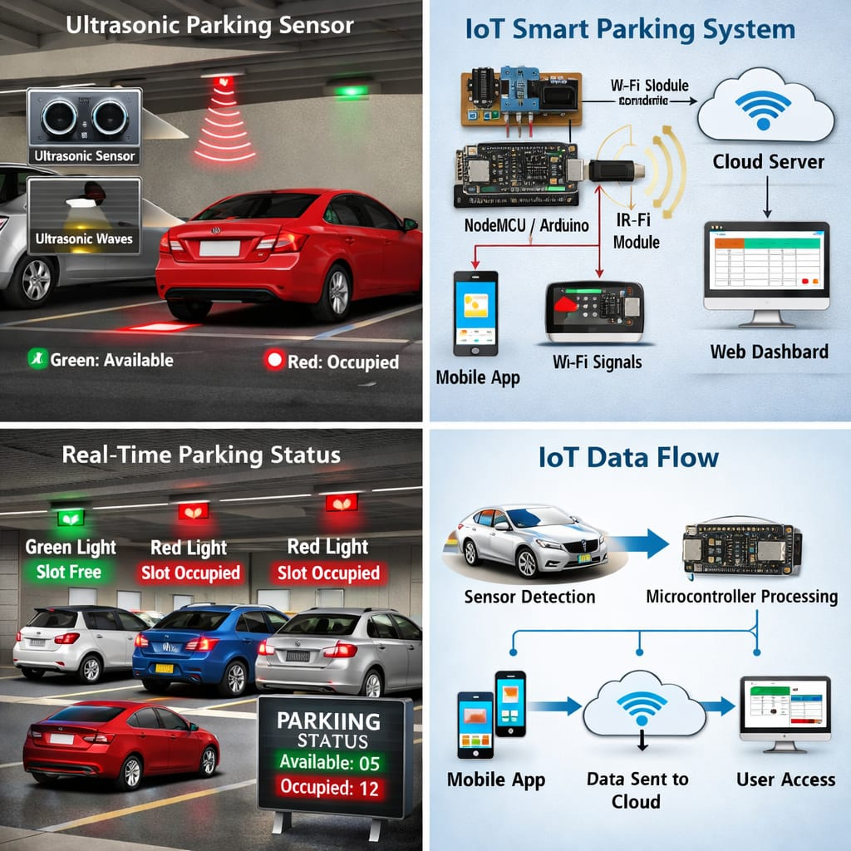

4.2 TRAFFIC LIGHT INDICATOR FOR SLOT AVAILABILITY:

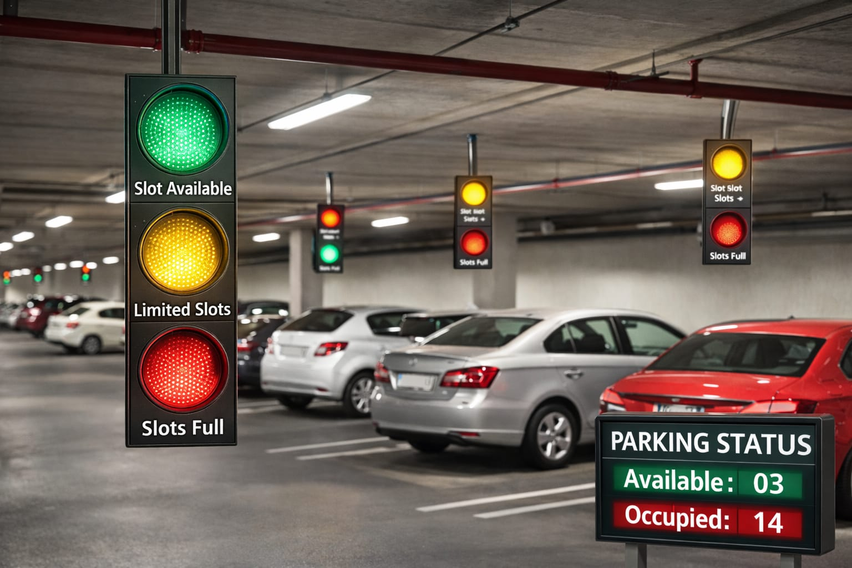

4.3COLLISION ALERT SYSTEM ARCHITECTURE:

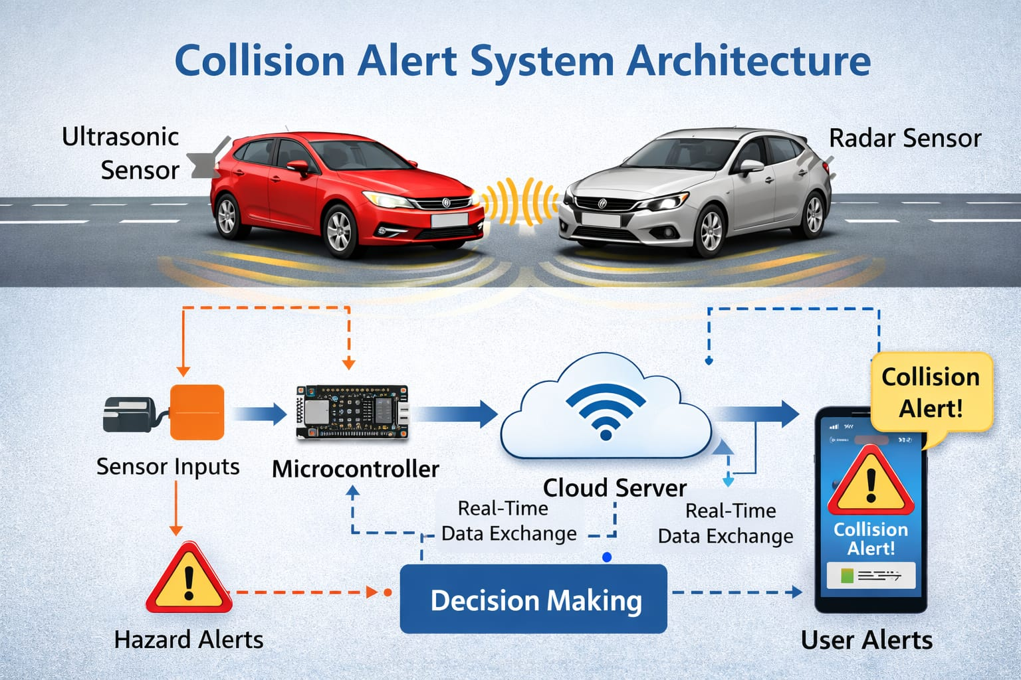

4.4 MOBILE WEBSITE INTERFACE FOR BOOKING:

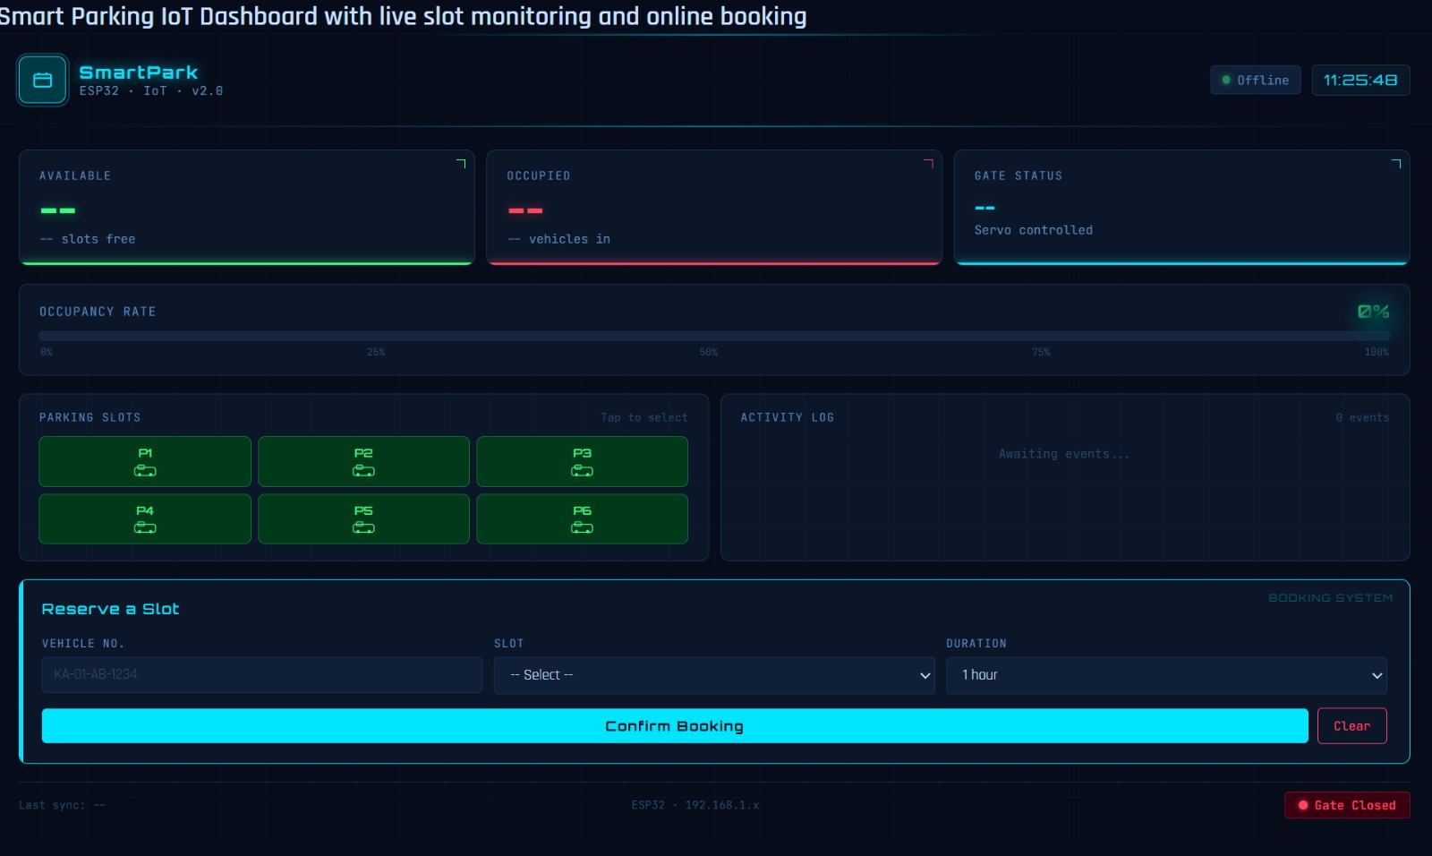

4.5 INTEGRATED HARDWARE SETUP:

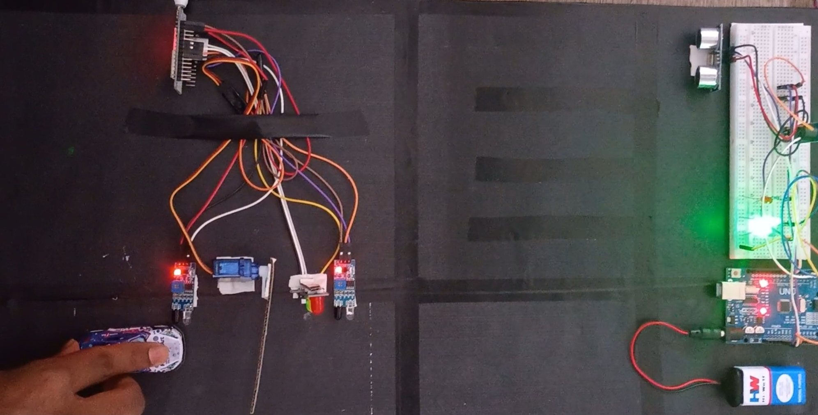

REFERENCES:

1. IEEE Xplore – IoT-Based Smart Parking Systems
https://ieeexplore.ieee.org/document/IoT-smart-parking (ieeexplore.ieee.org in Bing)
(Research papers on sensor integration, cloud platforms, and real-time parking management.)

2. ScienceDirect – Smart Parking Solutions Using IoT
https://www.sciencedirect.com/topics/computer-science/smart-parking (sciencedirect.com in Bing)
(Detailed studies on ultrasonic/IR sensors, wireless communication, and urban mobility impact.)

3. MDPI Sensors Journal – IoT Applications in Smart Cities
https://www.mdpi.com/journal/sensors/specialissues/IoTSmartCities (mdpi.com in Bing)
(Covers IoT sensor networks, cloud computing, and AI-based prediction models for parking.)

4. Springer – Intelligent Transportation Systems and IoT
https://link.springer.com/chapter/smart-parking-iot (link.springer.com in Bing)
(Explains methodologies, hardware/software integration, and case studies of smart parking.)

5. ResearchGate – IoT-Based Smart Parking System Implementation
https://www.researchgate.net/publication/IoTSmartParkingSystem (researchgate.net in Bing)
(Practical implementations, limitations, and future scope including AI and EV charging integration.)

